|  |
| --- |
|  |
| SharePoint Content Manager - User Guide |
| User Manual |
|  |
|  |
| **Last updated: 10/20/2022** |

|  |
| --- |
|  |

This document will provide users with instructions on how to use Cognillo’s SharePoint Content Manager™ tool.

Table of Contents

Introduction 3

Installation & Minimum Requirements 4

IMPORTANT: This program does not need to be installed on a SharePoint Server. 4

Minimum Hardware Recommendations 4

Supported SharePoint Versions 4

.NET Framework Required 4

Local Machine & Windows System Permissions Required 6

Anti-Virus, Offline Sync Folders (i.e. Google Drive, OneDrive, Drop Box, etc.) and Performance 6

SharePoint User Permissions Required 7

Office 365 Accounts 7

Getting Started 8

Quick Overview 8

Item Query 8

Copy Wizard 8

Copy List 8

Copy Term Store 9

Bulk Upload 9

Item Query 9

What can I use this for? 9

Starting an Item Query 11

Copy Wizard 15

What can be copied 15

Features & Notes on Behavior 15

*Limitations & Known Issues 16

Step One - Copy 16

Step Two - Paste 18

Step Three – Select Global Options 19

Step Four – Select Lists & Options 21

Step Five – Review & Start Job 25

Bulk Upload 26

Getting Started 26

Step One – Right click and select ‘Bulk Upload’ 26

Step Two –Click “Connect” and “Select Target” library 26

Step Three - Choose Options 27

Mapping Rules 29

Step Four - Click Upload 30

Progress Bar & Job Logs 31

Bulk Upload & Mapping Managing Metadata (MMD) (to Folder Names or Custom Values in bulk) 32

Step One – Managing Metadata on SharePoint 32

Step Two – Export the Excel file from SharePoint 33

Step Three – Right click and select ‘Bulk Upload’ 33

Step Four – Click “Connect” and “Select Target” library 34

Step Five – Drag & Drop 35

Step Six - Choose Options 36

Step Seven – Create Metadata Mapping CSV Template 37

Technical Support 39

# Introduction

This utility is part of the SharePoint Essentials Toolkit TM Suite. This utility is used to manage content in SharePoint sites.

# Installation & Minimum Requirements

Please see the “SharePoint Essentials Toolkit – User Guide” for installation instructions.

## IMPORTANT: This program does not need to be installed on a SharePoint Server.

## Minimum Hardware Recommendations

**Processor:** Minimum Dual-Core, 3GHz. Recommended Quad-Core 3GHz or higher  
We recommend Quad-Core 3GHz processor or higher when scheduling more than 20 Jobs at the same time.

**RAM:** Minimum 1GB available. Recommended 2GB or higher available

We recommend:

* At least 1GB of available RAM for jobs* with less than 200GB and less than 10K items to copy
* At least 2GB of available RAM for jobs* with 200GB to 500GB or with 10-100K items to copy
* At least 4GB of available RAM for jobs* with 500GB+ or with 100K items or more to copy
* At least 8GB of available RAM for jobs* with 1TBGB+ or with 500K items or more to copy

*Jobs – includes all jobs being run at one time, such as multiple jobs in a schedule for one or more sites

**Hard Disk:** 200MB Available Hard Disk Space (for the application files, logs, temp files and reports).   
Temp files are automatically cleared as needed. This is in addition to the disk space required by the SharePoint Essentials Toolkit.

## Supported SharePoint Versions

Microsoft SharePoint Online / Office 365

Microsoft SharePoint Server 2019

Microsoft SharePoint Server 2016

Microsoft SharePoint Foundation 2013

Microsoft SharePoint Server 2013

Microsoft SharePoint Foundation 2010

Microsoft SharePoint Server 2010

## .NET Framework Required

.NET Framework 4.5 or higher is required. If it is not found on the client machine, the user will be prompted to automatically download and install the prerequisite.

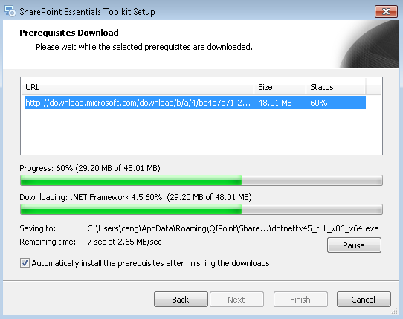

## Local Machine & Windows System Permissions Required

Please see the SharePoint Essentials Toolkit User Manual.

## Anti-Virus, Offline Sync Folders (i.e. Google Drive, OneDrive, Drop Box, etc.) and Performance

Please see the SharePoint Essentials Toolkit User Manual.

# SharePoint User Permissions Required

Users require specific SharePoint permissions to be able to use the tool, see the below points for the specific permission levels required:

* A member of “Site Collection Administrators” group
* Or have Full Control at Web Application level user policy
* Or have Full Control at Site (SPWeb) level

## Office 365 Accounts

* When copying Office 365 SharePoint sites, an Organizational account must be used, such as [user@mycompany.com](mailto:user@mycompany.com) or [user@mycompany.onmicrosoft.com](mailto:user@mycompany.onmicrosoft.com). Microsoft accounts (Windows Live IDs), such as [user@live.com](mailto:user@live.com) or [user@hotmail.com](mailto:user@hotmail.com), are not currently supported for authentication.

# Getting Started



## Quick Overview

This component has several features to help SharePoint users manage content. Use the “Item Query” feature to find specific content, text or even HTML code throughout the site easily. Below is a list of the main features:

### Item Query

* + This is a very powerful tool that allows a user to perform a query against items and files across one or more sites and site collections, avoiding heavy reliance on either a manual check or search which is time-consuming and often does not return the content you are looking for or in the data format that you can use for reporting. The tool allows you to export results easily to MS Excel.
  + Examples: Find all files larger than 50MB, or all files containing a specific web part, or all files containing a specific CSS reference.

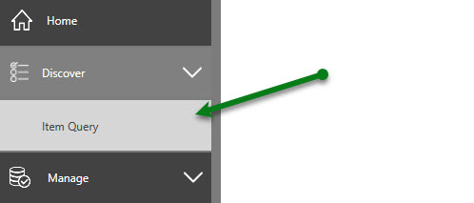

### Copy Wizard

* + Allows a user to copy a SharePoint Lists/Content Types/Site Columns from one site to another (they can be from the same or different environments and SharePoint versions)
  + SharePoint Lists include: All Lists and Libraries (including custom ones), Web Pages, Wiki Pages from a Source Site to a Target List.

### Copy List

* + This feature allows users to copy a SharePoint List or Library from one SharePoint site to another. The SharePoint sites can be on the same farm or a different farm

### Copy Term Store

* + This allows users to Copy Terms from a Site Collections Term Store from one location to another.

### Bulk Upload

* + This feature allows a user to upload files from a file share or their desktop PC to SharePoint. The tool can auto-rename (such as replace special characters), filter by date (such as only copy recent files), preserve modified and author information from files, mapping folder names to metadata, etc.

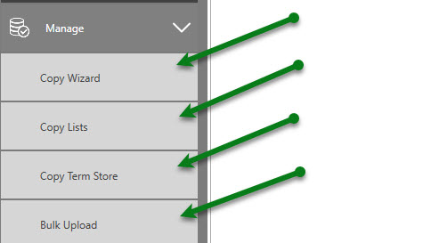

## Item Query

### What can I use this for?

This component can be used to query items in every list and library in every site (that you select) to build a single report (and their locations) that match certain criteria:

All items and files:

* modified by a specific user
* that match metadata
* that match a specific Content Type
* that contain a certain keyword (including within PDFs, Office documents and item metadata)
* that contain text that matches a regular expression (including within PDFs, Office documents and item metadata)
* more…

You can build these reports against an entire Farm, Web Application, Site Collection, subsite or specific SharePoint List.

### Starting an Item Query 1: Top Navigation Panel

There are several ways you can perform a query for Item Query.

1. From the top navigation panel, click the “Content” tile, and then click the “New Report” button.

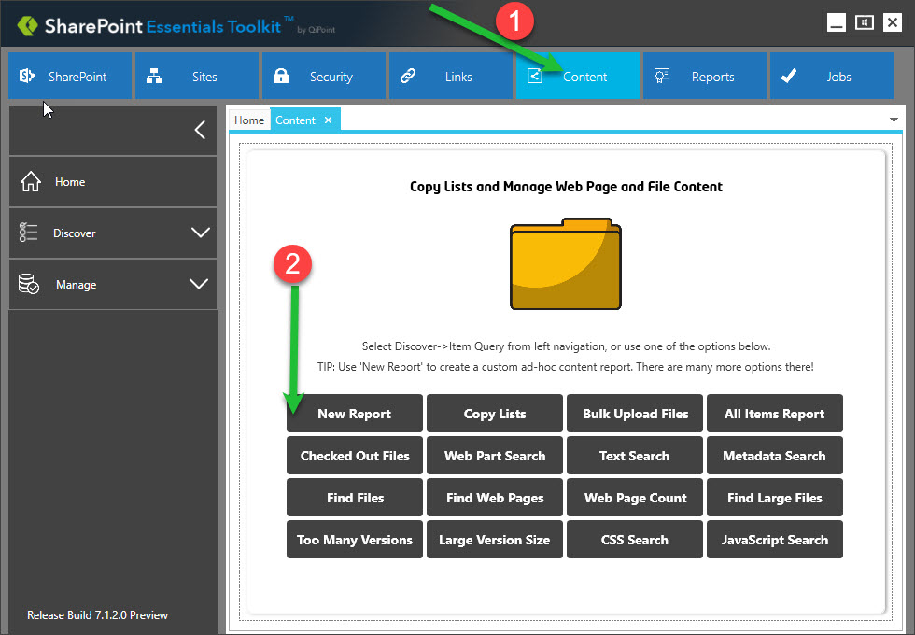

### Starting an Item Query 2: Side Navigation Panel

1. From the top navigation panel, click the “Content” tile, and then click “Discover” -> “Item Query” button via the left-side navigation panel.

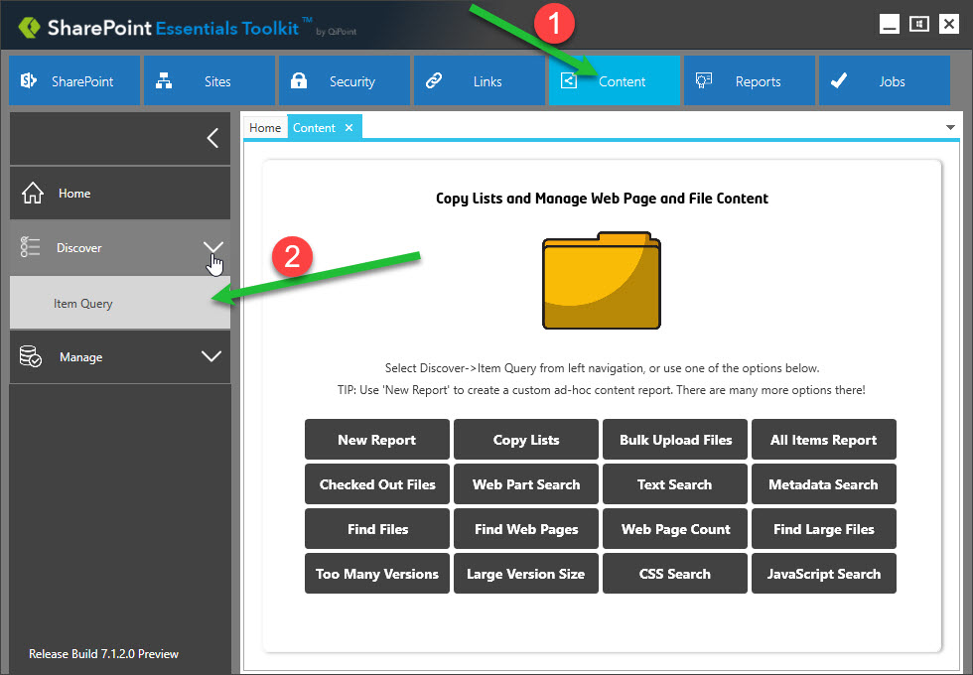

### Starting an Item Query 3: Home Page Dashboard

1. In the Home Page Dashboard, select one or more sites that you want to query.

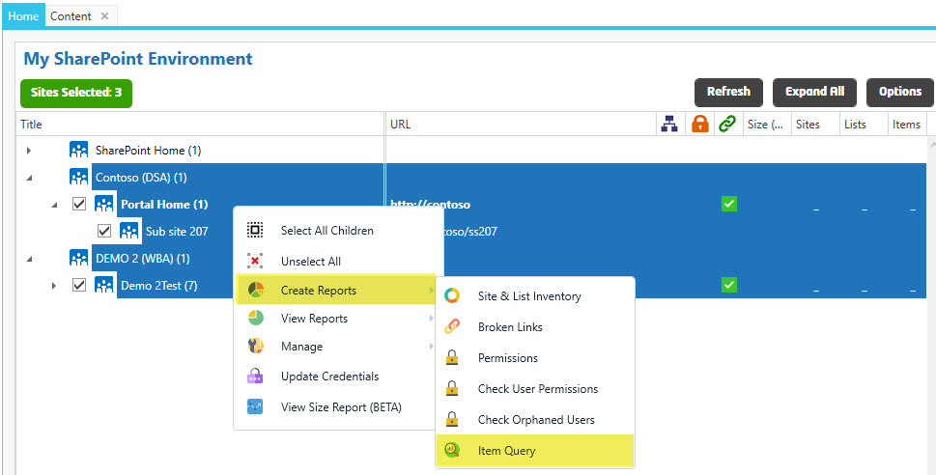

1. An “Item Query” window will open.
2. From here you can enter a Job Name, and then choose the criteria for the items you want to query (see the “Query Options” section) and include in the report:

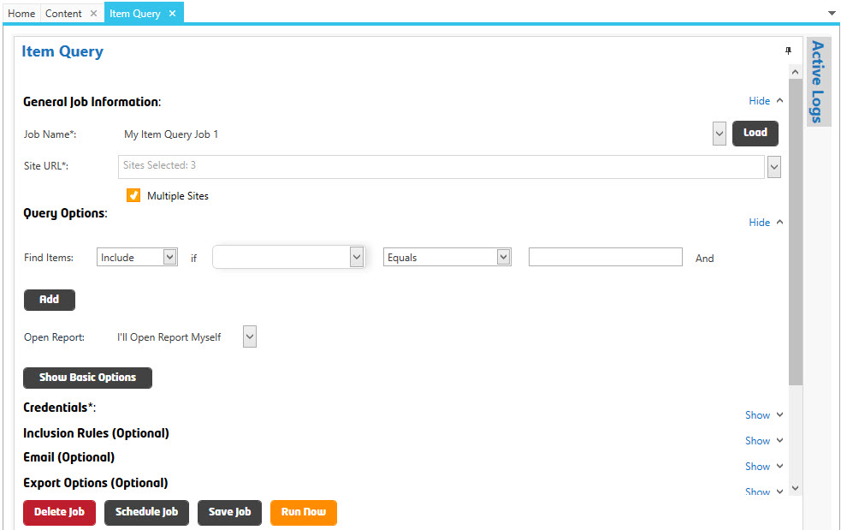

1. You can query items by Total Size (MB), Last Modified, Last Modified By, Created, Created By, Column/Metadata Value, Any Column Value, File Content (where the file contains matching string/text value), Content Type Name, Content Type Internal Name, Checked Out, and Version Count. Combine any of these queries (if applicable) in the report.

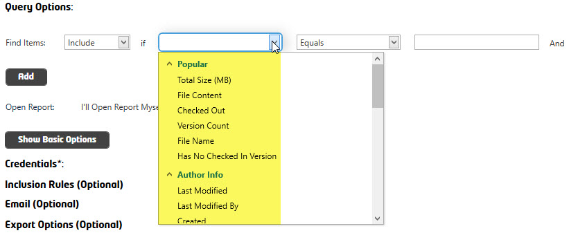

1. Once you have selected to **Include** or **Exclude**, and then the property (for example, “File Content”) to search within.
2. You can then determine the comparison from the dropdown. Select, for instance “Contains”.

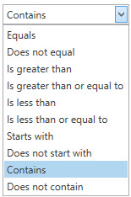

1. The text field can then be populated with the text value or values you are looking for in the content. For example, use the JavaScript function “**function ChangeDivColor**“.



1. Ensure the **Credentials** are set that match the SharePoint connection that you selected. The bulk of the configuration is then completed within the **Query Options** section of the **Item Query** window.
2. With any query in the toolkit, you can add **Inclusion Rules**, **Email** options and **Export** option criteria. For simplicity, leave these options with their default values.
3. Now click **Save job**.
4. Click the “Run Now” button to initiate the newly created job to run or “Schedule Job” to run query/job at a future date and time.

Once the job completes, it will first show a completed scan in the “Active Logs” window. A list of results (Item/File/Page) from all the sites and lists queried will display after clicking the “Open Report” button: 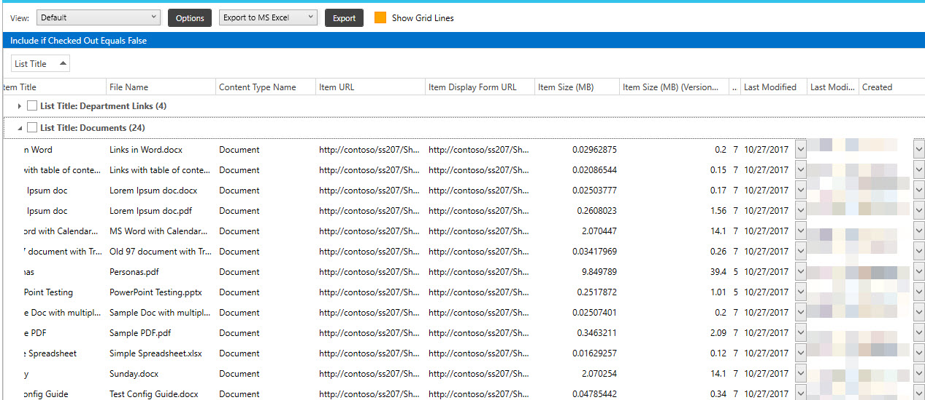

## Copy Wizard

### What can be copied

This component can be used to copy:

* SharePoint Lists or Libraries (including items and files)
* SharePoint Web Part Page Libraries and Wiki Page Libraries *
* SharePoint List Items, Files and Folders
* SharePoint Content Types
* SharePoint Site Columns

*See limitations below

You can copy from one Farm, Web Application, Site Collection or subsite to another, for example, a SharePoint List or Library from SharePoint 2010 to SharePoint Online (Office 365) or within the same SharePoint environment.

### Features & Notes on Behavior

When Copying Lists

* If the Content Type is not found in target, the tool will retrieve the ‘Base Type’ of the source Content Type and use that for the target Item Content Type. For example, if you have a custom Content Type called “ABC Content Type” based on a Document Set SharePoint Content Type, the tool will first try to use the custom Content Type (“ABC Content Type”) and, if it is not found in target, it uses the “Document Set” base Content Type.
* If a Permissions Level is used in the source and not found in the target, the Permission Level will be created in the Target Site automatically and assigned accordingly to the List/Item/File/Folder.
* Document IDs: If the Documents ID service is already enabled in the destination site and "Retain Document Id" is unchecked, then, the tool will copy Document ID field to the destination list. It will not handle Document ID separately and creates a new field called Document ID (which will be unmanaged by SharePoint and it would be recommended for you to remove this column).
  + If the Document ID column is present in destination site and Retain Document ID option is checked, then the tool will copy Document ID field values to target.
  + If the Documents ID service is not enabled in the destination site and "Retain Document ID" is checked, then the tool attempts to activate the “Document ID Service” feature in destination site collection before copying. However, sometimes after enabling the feature, the Document ID column is missing from List columns as this feature sometimes will activate according to timer job, see <https://social.technet.microsoft.com/Forums/sharepoint/en-US/544f0419-eb30-4c09-8cc7-6d2ba6c35697/sp2013-new-document-library-missing-document-id-column-possible-bug?forum=sharepointgeneral>

### *Limitations & Known Issues

The following are not currently supported by the tool: (coming soon in an upcoming update)

* SharePoint Workflows
* Copying Web Part pages or Wiki pages that have:
  + SOURCE: SharePoint 2013, 2016 or SharePoint Online
  + TARGET: SharePoint 2010
  + Are not fully supported, the pages will copy, but some web parts are not copied over and will display an error in the logs.
* Copying Web Part pages or Wiki pages that have:
  + Calendar Web Parts, the View of the Calendar web part is not preserved on the target
* Mapping Permissions or Users
* Mapping Content Types
* Mapping Metadata
* Document IDs: If the Documents ID service is already enabled in the destination site and "Retain Document Id" is unchecked, then, the tool will copy Document ID field to the destination list. It will not handle Document ID separately and creates a new field called Document ID (which will be unmanaged by SharePoint and it would be recommended for you to remove this column). See ‘Features & Notes on Behavior - Document ID’ for more information on copying the Document ID values from source to target list.

*After you have added sites to the Home Page Dashboard (see the “SharePoint Essentials Toolkit User Manual” on how to do this), you can perform a Copy operation by doing the following:*

### Step One - Copy

(Source) Right click on the Site you want to copy FROM (the ‘Source’):

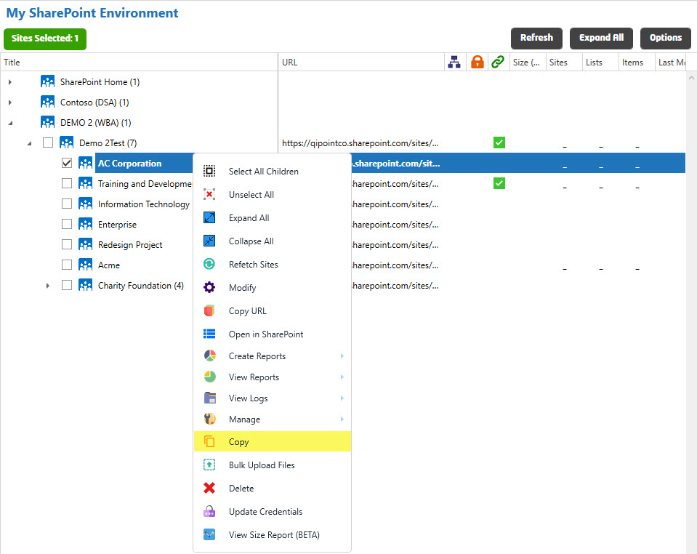

### Step Two - Paste

(Destination) Right click on the Site you want to copy TO (the ‘Target / Destination’)

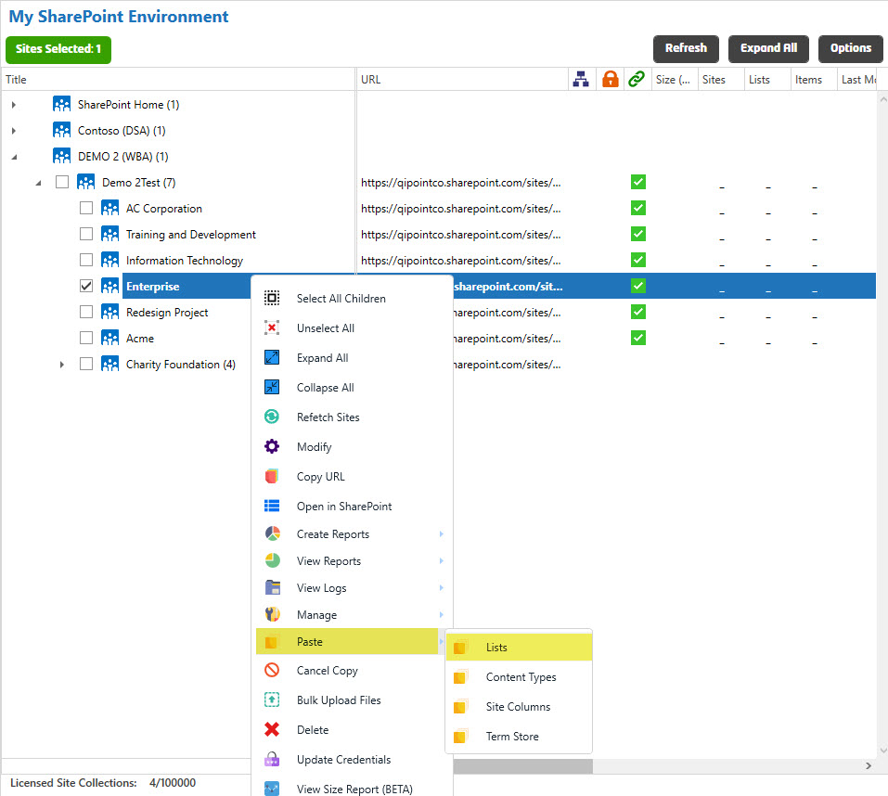

### Step Three – Select Global Options

The system will then prompt you with the below window. Here you will set the options that will be applied to all Lists copied in this job.

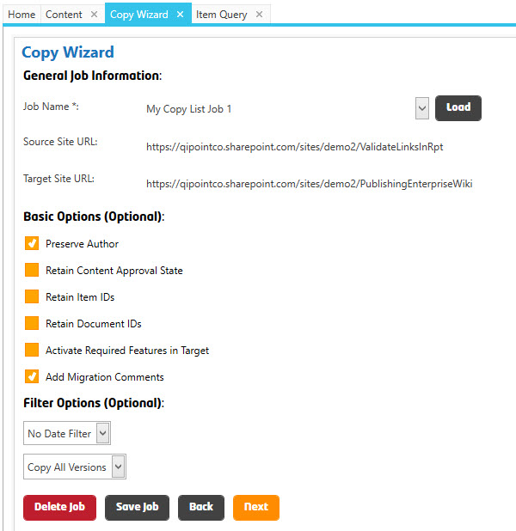

#### *Global Options*

The below options will be applied to all SharePoint Lists & Libraries copied in this job.

##### General Job Information

###### Job Name

This is the Name of the job. The system creates a folder in the report directory for every job. You can use the same Job Name to group reports. The job’s name is used to help identify the report if scheduled and will appear in the Job History section. You must rename the job if you want to save the job for future re-use.

###### Source Site URL

This is the Site where you copied FROM.

###### Target Site URL

This is the Site where you will be copying TO.

##### Basic Options (Optional)

###### Preserve Author

When SharePoint content is copied, select this option ON to keep the Last Modified By User and Last Modified Date in the target site.

###### Retain Item IDs

Use this option to keep SharePoint Item IDs from source to target. This is important when copying lists that have lookup fields to other lists, otherwise, the references can be incorrectly set.

##### Filter Options (Optional)

###### Date Filter

When SharePoint content is copied, you can filter results that are copied by Date Last Modified. For example, you may want to exclude old content that was not modified in the last 12 months.

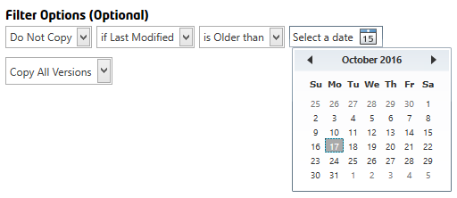

###### Version Filter

When SharePoint content is copied, you can choose if all versions will be copied over or if only certain versions should be copied, such as only Published versions.

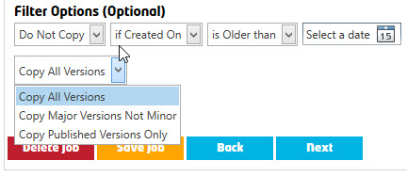

### Step Four – Select Lists & Options

After clicking the “Next” button from the previous page, the system prompts you with the below window.

From here, you need to select the Lists & Libraries you want to copy (from the ‘source site’) to the ‘Target Site’.

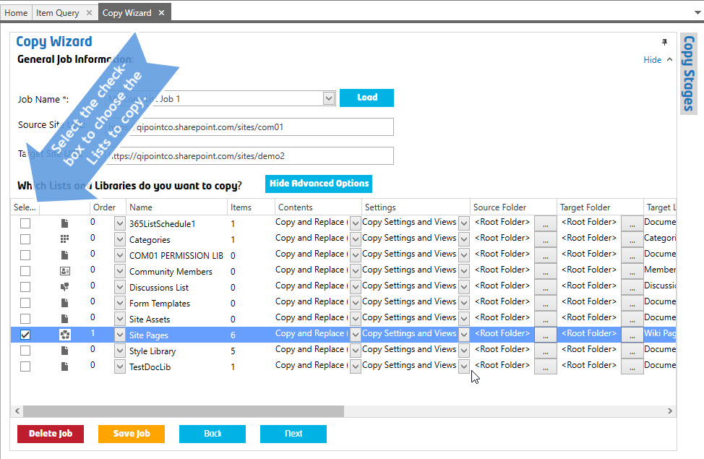

#### List Level Options

Each List has several options you can choose from. Below are descriptions for each of these options.

##### Order

You can optionally set the order of when this List should be copied. You may want to change this value if there are Lists with Lookup Columns to other lists, so then you can ensure those lists are present as needed.

##### Name (Read Only)

This is the Name of the SharePoint List as found in the Source Site. This value is not editable and is only for informational purposes.

##### Items (Read Only)

This is the number of SharePoint List Items/Files/Folders, as found in the Source Site. This value is not editable and is only for informational purposes.

##### Contents

Select how you want to handle copy conflicts for list items. Such as if a file or web page with the same name exists in the target list.

You can choose from one of the following, the default is “Copy (Merge)”

**No**No items will not be copied, only the SharePoint List will be created.

**Copy (Overwrite)**If a file is found with the same name, the file will be OVERWRITTEN. If versioning is enabled on the target list, a new version will be created for the target list item. SharePoint Items that do not have a conflict will get copied to the target list.

Page Library files (*.aspx pages) – With this option, SharePoint Pages will be copied exactly as from Source, URLs within the page will be automatically fixed to match the target, ‘mirrored’. This can be useful if copying from a PRODUCTION Site to a STAGING Site for example, or if there are heavy customizations in the web page that need to be copied over. List View Web Parts will be added but you will receive an error “List does not exist in target’ if the List with the same List Name does not exist in the target Site. Using this option will usually detach the Web Page from the Site Definition.

**Copy (Merge) – Default Option**If a file is found with the same name, the file will not be updated. There will be no change in the target list item. You will see a warning in the Active Logs that the file already exists and was skipped. SharePoint Items that do not have a conflict will get copied to the target list.

Page Library files (*.aspx pages) – In most cases, you want to use this option. With this option, SharePoint Pages will be CREATED as NEW web pages in the target library, URLs within the page will be automatically fixed to match the target. Web Parts will automatically be added and recreated in the target web page. List View Web Parts will be added but you will receive an error “List does not exist in target’ if the List with the same List Name does not exist in the target Site. Using this option will NOT detach the Web Page from the Site Definition, however in some cases you will need to click “Revert to Site Definition” if prompted in the web page.

**Copy (Changes Only)**If a file is found with the same name, the file will only be OVERWRITTEN if the SOURCE List item has a ‘newer’ last modified date than the target list item found. There will be no change in the target list item if the target list item date is the same or newer. You will see a warning in the Active Logs that the file already exists and was skipped since the Last Modified Date is the same or newer than Source list item. SharePoint Items that do not have a conflict will get copied to the target list.

Page Library files (*.aspx pages) –With this option, SharePoint Pages will be CREATED as NEW web pages in the target library if they do NOT already exist and if the web page already exists, but is older than the source Last Modified Date. URLs within the page will be automatically fixed to match the target. Web Parts will automatically be added and recreated in the target web page. List View Web Parts will be added but you will receive an error “List does not exist in target’ if the List with the same List Name does not exist in the target Site. Using this option will NOT detach the Web Page from the Site Definition, however in some cases you will need to click “Revert to Site Definition” if prompted in the web page.

##### Settings

This option allows the user to copy the source List Settings and Views to the target.

You can choose from one of the following, the default is “Copy Settings and Views”

**No**Only the SharePoint List will be created; the Settings and Views will not be copied.

**Copy Settings**Only the SharePoint List Settings will be copied.

**Copy Views**Only the SharePoint List Views will be copied.

**Copy Settings and Views – Default Option**Both the SharePoint List Settings and Views will be copied.

##### Source Folder

You can choose if you want to copy List Items FROM a specified folder.

##### Target Folder

You can choose if you want to copy List Items TO a specified folder.

##### Target List Template

You can choose to change the target List Template used. NOTE: Not all conversions are supported by SharePoint. This can be useful if you need to convert a Generic List template to use a Custom List Template for example

##### Include Sub Folders

You can choose if you want to include sub folders when copying from the source to target. If you select ‘No’, then all files and items will be copied from only the current folder in the source (specified in the ‘Source Folder’ column in the tool, see above).

##### Permissions

You can choose if you want to copy List Items permissions.

**Do Not Copy – Default Option**List permissions will NOT be copied from source to target.

**Copy (Overwrite)**List permissions will be copied from source to target. If the List has existing SharePoint Groups, Domain Groups or Users that exist with the same name in the target, they will be OVERWRITTEN with the object(s) in the source. Use this option if you want the target List to have exactly the same permissions as the Source.

**Copy (Merge)**List permissions will be copied from source to target. If the List has existing SharePoint Groups, Domain Groups or Users that exist with the same name in the target, they will be MERGED with the object(s) in the source.

##### Copy Folder Structure

Settings this option ON will include all folders to be copied to the target. If this is turned OFF/Disabled, then only files will be copied, not the folders that they may belong to. This will result in a more ‘flattened’ structured target, without folders. NOTE: Files with the same name may have conflicts when getting saved to the target since there are no folders to isolate/separate them.

##### Copy Columns

Setting this option ON will include copying all columns (metadata) from the source to the target. If this is not enabled, only files will be copied but not the attached field data. If you are copying a List and not a Library, then only the Title field will be copied to the target.

##### Filter Items Using View

You can choose if you want to Filter Items that are being copied by specifying a SharePoint View from the drop-down list. The drop-down list will show you all available views for that List in the Source. By default, no View Filter is used. NOTE: This can be useful if you are copying large lists (over 5000 items) and need to break the Job into smaller ‘pieces’. You can create a view based on ID field, such as ID greater than 1000 and less than 1000 in two (or more) views to allow the Jobs to complete faster and run in parallel.

##### Target List Name

You can specify a NEW List Title in the target site. To do this, simply rename the text value. By default, this will be the same List Name as from the source.

##### Target List Internal Name

You can specify a NEW Internal List Name in the target site. To do this, simply rename the text value. By default, this will be the same Internal List Name as from the source. The Internal List name is used in the URL of the list and other areas such as when filters or search queries are used.

### Step Five – Review & Start Job

Review and confirm your changes for the target site.

When ready, click the “Start” button.

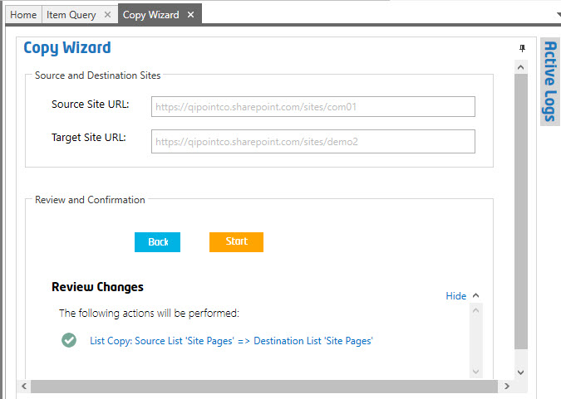

## Bulk Upload

### Getting Started

You can use this tool to bulk upload from file shares or from your desktop PC to SharePoint.

### Step One – Right click and select ‘Bulk Upload’

From the Home Page Dashboard, right click on the site that you want to bulk upload files to.

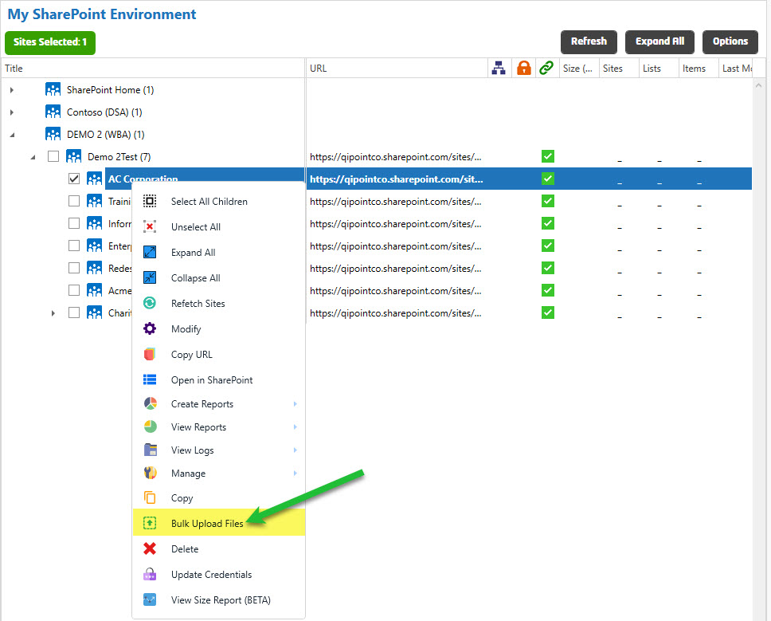

### Step Two –Click “Connect” and “Select Target” library

1. You can now enter a unique Job Name or use the default option. Click the “Connect” button to retrieve the SharePoint Lists from the site.
2. You should then be able to see a list of the Libraries to upload to the target site.
3. Select the library or folder within a Library to upload to. A preview of the files is visible in the right-hand panel “Destination Details (Preview Existing Content)”.
4. Click the “Next” button.

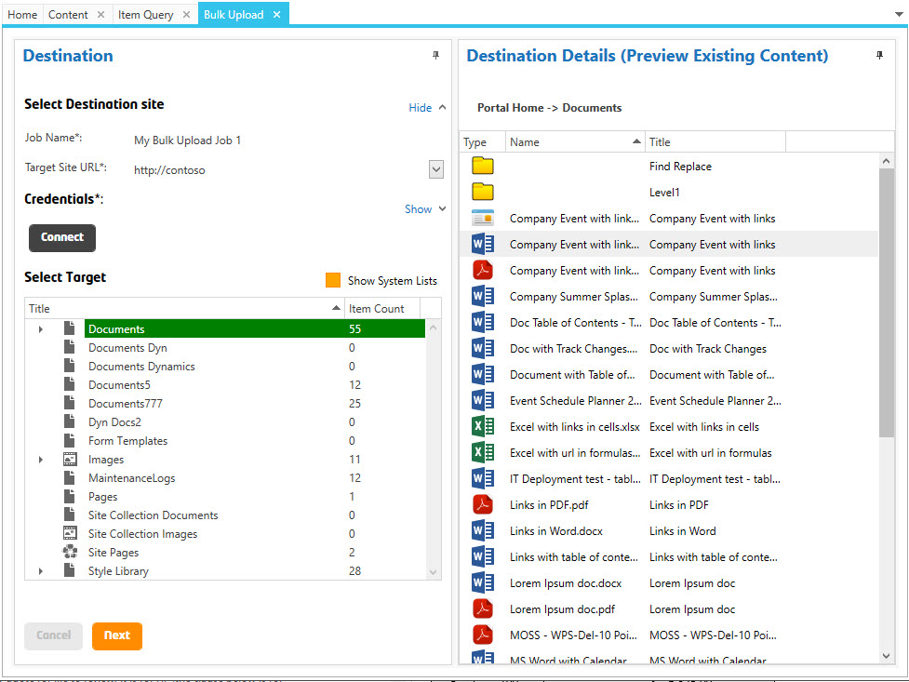

### Step Three - Choose Options

1. Select any options needed. You may use renaming rules to auto-replace invalid characters that would normally cause a ‘copy-paste’ to fail since SharePoint blocks certain file characters.

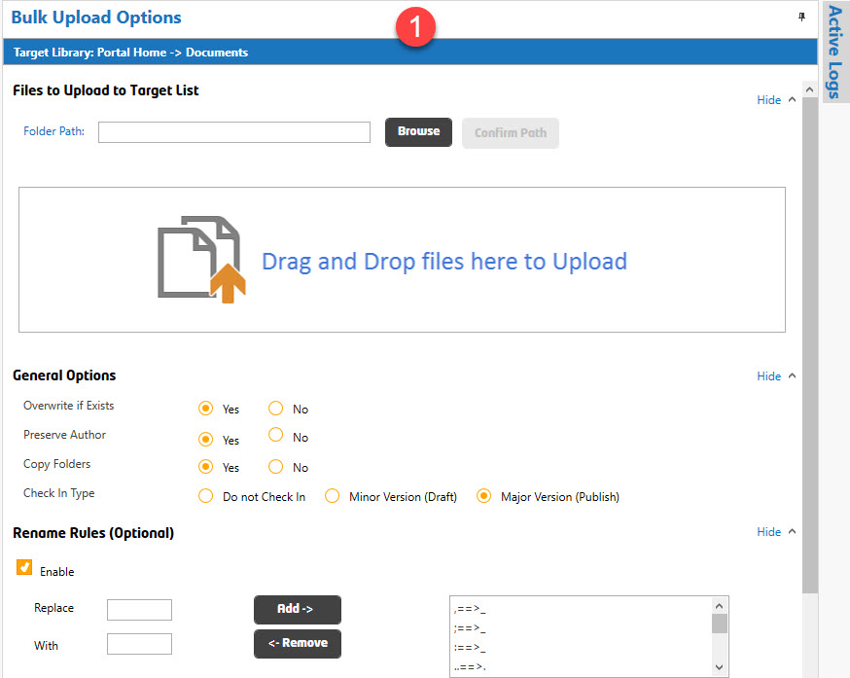

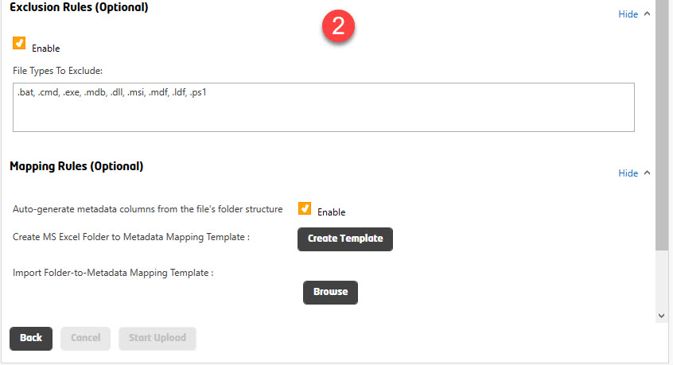

### Mapping Rules

You may use mapping rules to copy folder names to specific meta-data columns.

1. Drag and Drop files that you will be importing into the target site.

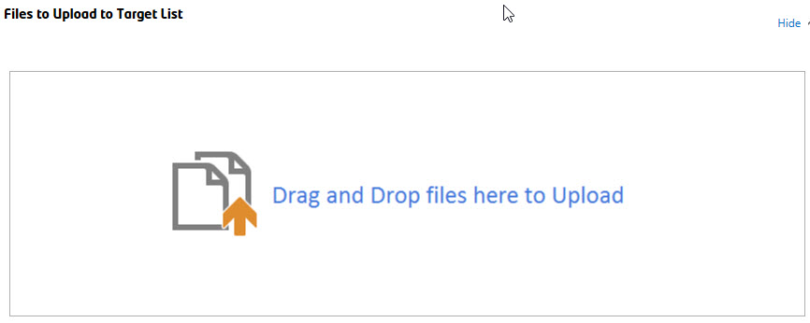

NOTE: You will not be able to Drag and Drop into this location if you run the program as a different user, such as using ‘Run as Administrator’.

1. Click the ‘Create Template’ button and the tool will automatically create a CSV file (used to set meta-data for the files that are being imported).
2. Copy the path that appears in the textbox.

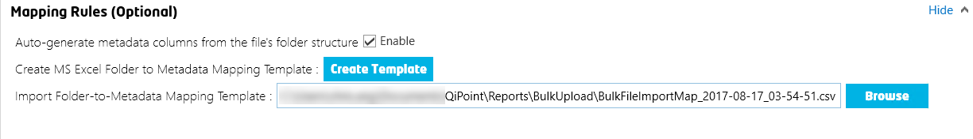

1. Paste this path into Windows File Explorer to open the CSV file.
2. The CSV file should open, and you may begin updating the metadata to be set for each item. See below for a definition of the columns. Folder Names will be used in the path to try to populate the Item Metadata. If the SharePoint Column does not already exist in the target list, the tool will automatically create the column.
3. Save the updated CSV.

##### Mapping Rules CSV Columns

FilePath

Do not change: this is the physical path the tool uses to retrieve the files for uploading to SharePoint.

NewFileName

You may provide a new file name for the item here or leave as-is. The File Name will also be applied automatically to the ‘Title’ column.

Column[x]

You must change the name of the column for the tool to update the metadata. Any column header in the CSV file that begins with ColumnN (N being a number) will be skipped and not used for updating.

### Step Four - Click Upload

This will begin the file upload to SharePoint. You should see the progress in the Active Logs window. If there are any errors, they will appear in red.

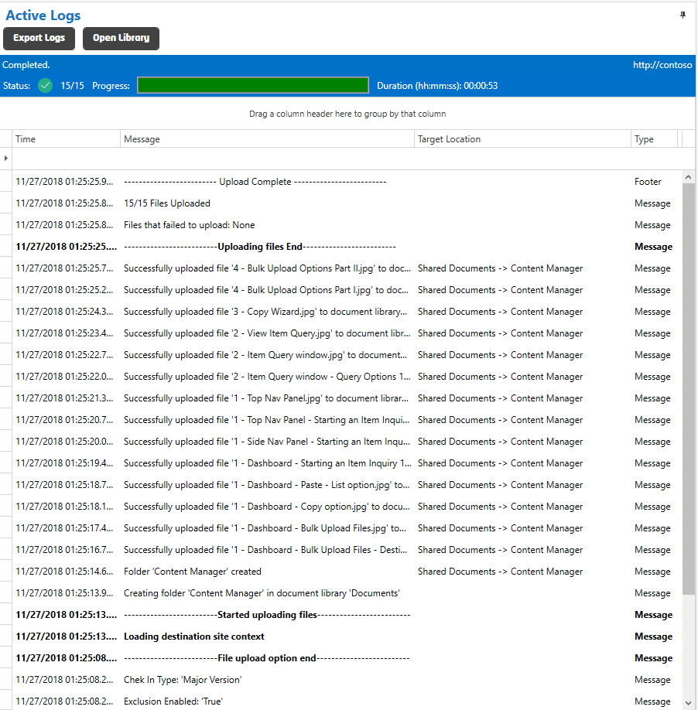

## Progress Bar & Job Logs

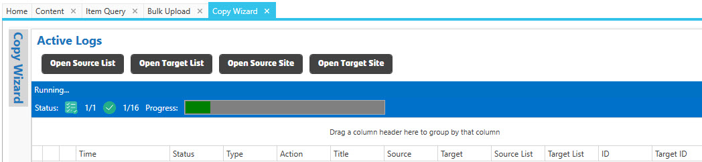

As the Job is running, a progress bar will indicate the number of SharePoint Lists remaining and the total number of items to be copied.

You will see the Active Logs populate with items as they are copied from Source to Target.

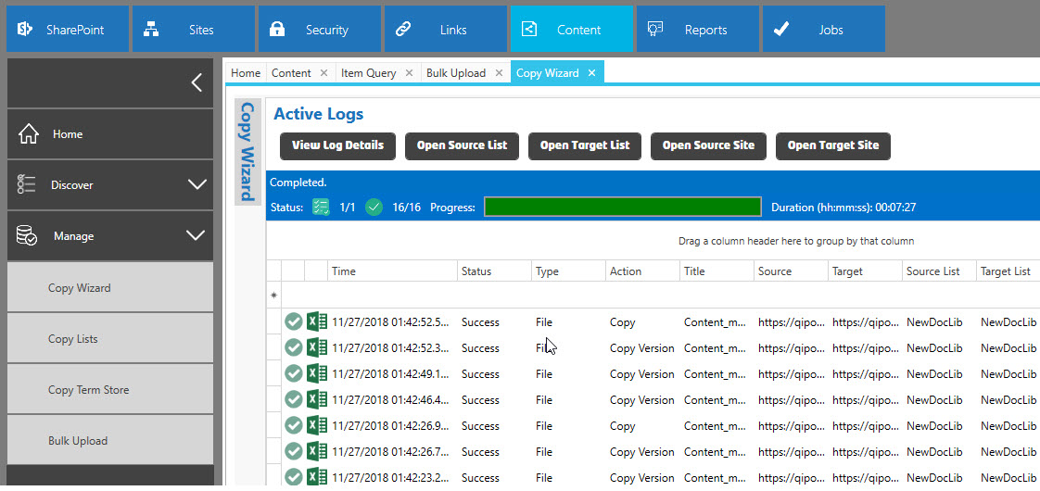

## Bulk Upload & Mapping Managing Metadata (MMD) (to Folder Names or Custom Values in bulk)

You can use this tool to bulk upload from file shares or from your desktop PC to manage metadata on SharePoint.

### Step One – Managing Metadata on SharePoint

Prerequisite: Create a Document Library or List with metadata columns.

1. Click the “+” button on the Document Library list.
2. Select the choice “More” and the “Settings -> Create Column” page appears.

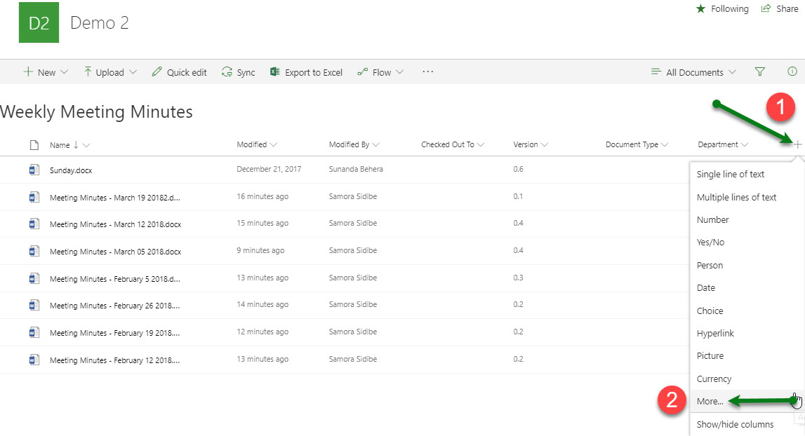

1. Enter a Column name, and then mark the radio button “Managed Metadata”. The page refreshes and the “Term Set Settings” section appears along with other areas.
   * “Use a managed term set:” or “Customize your term set:” to associate values for the columns, based on your requirements. (Note: The term will be available to users in the site collection.)
2. Click the “OK” button and the system returns the user to the library page.
3. If no default value was entered in the prior steps, click the “Quick edit”, populate the intended cells, and finally click the “Done” button.

### Step Two – Export the Excel file from SharePoint

1. Click the “Export to Excel” button, for example, from the Document Library. The ‘query.iqy’ file downloads.
2. Launch the ‘query.iqy’ à click ‘Enable’ button if the Microsoft Excel Security Notice popup appears.
3. (The Excel file opens.) Look for special character format in the metadata columns, for example, look for the metadata, denoted with a special format: "7;#Accounting”. (This information will be required in the later steps.)

### Step Three – Right click and select ‘Bulk Upload’

From the Home Page Dashboard, right click on the site that you want to bulk upload files to.



### Step Four – Click “Connect” and “Select Target” library

1. You can now enter a unique Job Name or use the default option. Click the “Connect” button to retrieve the SharePoint Lists from the site.
2. You should then be able to see a list of the Libraries to upload to the target site.
3. Select the library or folder within a Library to upload to. A preview of the files is visible in the right-hand panel “Destination Details (Preview Existing Content)”.
4. Click the “Next” button.



### Step Five – Drag & Drop

1. Drag and Drop files that you will be importing into the target site.



### Step Six - Choose Options

1. Review, confirm, and select additional options (if applicable). For example, you may use renaming rules to auto-replace invalid characters that would normally cause a ‘copy-paste’ to fail since SharePoint blocks certain file characters.
2. (Create ‘MS Excel Folder to Metadata Mapping Template’ process is explained in “Step Seven – Create Metadata Mapping CSV Template”.)





### Step Seven – Create Metadata Mapping CSV Template

1. Click the ‘Create Template’ button and the tool will automatically create a CSV file (used to set meta-data for the files that are being imported).
2. Copy the path that appears in the textbox.



1. Paste this path into Windows File Explorer to open the CSV file.
2. The CSV file should open, and you may begin updating the metadata to be set for each item/record. See below for a definition of the columns. Folder Names will be used in the path to try to populate the Item Metadata. If the SharePoint Column does not already exist in the target list, the tool will automatically create the column.

##### Mapping Rules CSV Columns

FilePath

Do not change: this is the physical path the tool uses to retrieve the files for uploading to SharePoint.

NewFileName

You may provide a new file name for the item here or leave as-is. The File Name will also be applied automatically to the ‘Title’ column.

Column[x]

1. You must change the name of the column for the tool to update the metadata. Any column header in the CSV file that begins with ColumnN (N being a number) will be skipped and not used for updating.
2. Recall the ‘query.iqy’ in [Step Two] above; it includes the Excel file with the special character/metadata.
3. Save the updated CSV file. (The system may prompt you to close the updated CSV file if it’s still opened.)
4. Click the “Upload” button. The metadata will upload to, for example, the Document Library in SharePoint. You should see the progress in the Active Logs window. If there are any errors, they will appear in red.

# Technical Support

If you need technical assistance, not to worry! We offer several ways to get in touch with our support team.

<https://www.congillo.com/support>

We are here to help!